## Section I: Develop Point of Sale Infrastructure

### Lesson 1: Configure Product Departments

**Details:** Develop the Product Department(s) across your city or which will serve as the locations where your Point of Sale (POS) products will be sold

* + - Develop a single department, and name the department to reflect the name of your city (e.g., City of Vancouver)
    - Note: All centres , which were created in Reservation Module, will sell the same POS items
    - *Tip: Administration Tab > POS Settings > Product Departments*
    - **Product Departments:** Entities in ActiveNet which serve to categorize a range of POS Products across an organization

### Lesson 2: Configure Product Classes

**Details:** Develop the Product Classes that will house your POS products, serving as categories under the broader product department

* + - Create three separate classes for your POS products, as follows:
      * Drop-ins
      * Rentals
      * Concession
    - Apart from giving each product class a description, be sure to link each product class to the department created in the above lesson
    - Note: Every product that is sold through the POS module will fall into one of these categories
    - *Tip: Administration Tab > POS Settings > Product Classes*
    - **Product Classes:** A categorization in ActiveNet which groups like POS Products, existing under the broader Product Department(s) across an organization

### Lesson 3: Configure Product Sub-Classes

**Details:** Develop POS Product Sub-Classes, further dividing the Product Classes created in the above lesson

* + - Divide up the Concession product class by creating the following sub-classes:
      * Food
      * Drink
    - Apart from giving each sub-class a description, be sure to link each sub-class to the appropriate product class created in the above lesson
    - Note: The Drop-ins and Rentals product classes do not require sub-classes
    - *Tip: Administration Tab > POS Settings > Product Sub-Classes*

### Lesson 4: Create a General Ledger (GL) Account for POS Product Fees

**Details:** Develop a GL account to serve as a bucket for collecting fees from POS product sales. GL accounts are reported to the organization’s General Ledger and represent how an organization divides up their revenue for year-end reporting.

* Assign appropriate name, number, and type for the GL account
* *Tip: Administration Tab > Financial Settings > GL Accounts*

## Section II: Configure Point of Sale Products

### Lesson 1: City-wide Point of Sale Product Listing

**Details:** Use the following diagram to help complete the subsequent lessons in this section

* + - The diagram provides the names of the products which will be sold through the POS module, as well as their respective prices
    - Note: The products listed in the diagram will, by default, be available across all of the centres in your city.

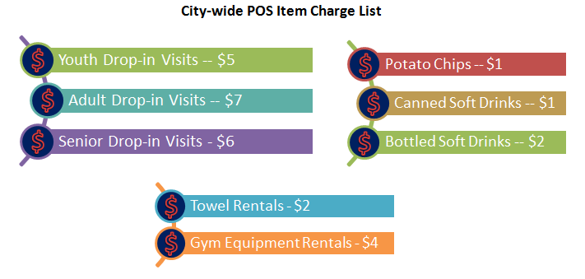

### Lesson 2: Create Point of Sale Products: General

**Details:** Using the POS Product Listing diagram above, develop the products that will be sold through the POS module across your city’s centres

* + - Ensure that each product is named and given an appropriate description
    - Assign each product to the single city department, and further assign each product to their appropriate class and sub-class (if necessary)
    - Configure the general settings such that each product is allowed to be sold individually
    - Ensure the system log’s the product’s usage in order to report on product sales
    - Note: It’s common practice to add the centre’s identity besides the name of the product (eg. “Youth Drop-in Visits KCC” for Kitsalano Community Centre) which means you will want to create a product for each separate center. This allows for proper tracking of product inventory.
    - *Tip: Administration Tab > POS Settings > Products*

### Lesson 3: Create Point of Sale Products: Product Fees & Inventory

**Details:** Using the POS Product Listing diagram above, implement the product fees for the products that were developed in the previous lesson

* + - Using the prices listed, enter in the fees for each POS product
    - Configure the product fee settings such that, by default, each product is selected on a single-sale basis
    - Ensure that the POS Product Fees GL Account is connected to the fees created for each product
    - Ensure that inventory on chips and bottled soft drinks are tracked with a re-order point of 10. Canned soft drinks have a reorder point of 60.
    - Enter appropriate reorder alert email address
    - *Tip: Administration Tab > POS Settings > Products > Product Fees*

### Lesson 4: Adjust Inventory

**Details:** Assign inventory count to appropriate products

* + - Update the physical count of each inventory item to 30
    - *Tip: Administration > POS Settings > Inventory Adjustment*

## Section III: Creating POS Layout

### Lesson 1: Develop Point of Sale Layout

**Details:** Building upon the system-standard POS layout, assign buttons for each POS item created in this module

* + - After navigating to the Standard POS Layout in the system, begin configuring the buttons of this layout to include all new POS products that have been created
    - When configuring each button, ensure that:
      * Button type is configured correctly as “Sell a Product”
      * The correct product is selected as the item to sell, and it’s appropriate settings are prefilled
      * The button appearance is configured so that each product is represented by its own individual colour
    - Note: In order to have a large button for a single product, you must configure two adjacent buttons with similar settings. The “copy” feature dropdown menu in the button settings will aid with this task
    - Use the illustration below to help structure the buttons in your POS layout



* + - *Tip: Administration Tab > POS Settings > Layouts*